UNIT 5
Lesson 2 – PLACES IN MY TOWN

- 1 a) Look at the pictures. Where are the people?
Talk to your classmate.
Pogledaj sličice. Gdje se nalaze ljudi?
Porazgovaraj s prijateljem iz razreda.

1  2 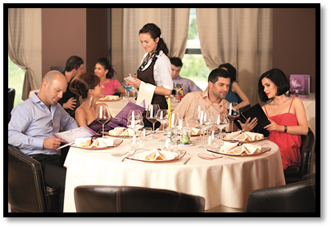

3  4 

5 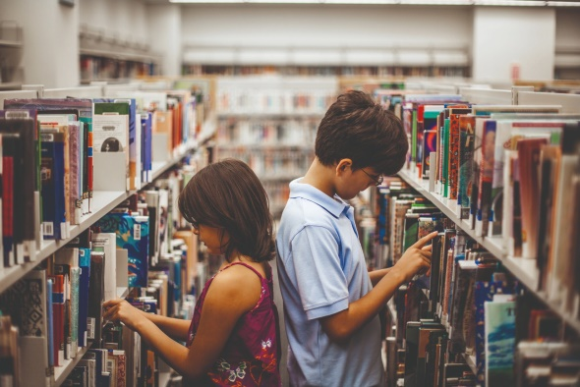

b) What are they doing?
Match the pictures to the sentences.
Put the picture's number next to the sentence.
Što rade ljudi na slikama. Usporedi slike s rečenicama koje ih opisuju.
Stavi brojeve slika u kućice pored rečenica koje ih opisuju.

A They are shopping.
One kupuju.
4
B They are choosing the books to read.
Oni biraju knjige za čitanje.

C The lady is buying fruit and vegetables.
Gospođa bira voće i povrće.

D The people are eating.
Ljudi jedu.

E The girl is exercising.
Djevojka vježba.

c) Match the pictures to their names.
Poveži slike mjesta s riječima koje ih opisuju.

2
A MARKET (tržnica)

B SHOPPING CENTRE (trgovački centar)

C SPORTS CENTRE ( sportski centar)

D RESTAURANT (restoran)

E LIBRARY (knjižnica)

- 2 How about you? Do you…? Circle YES or NO.
A ti? Je li ti…? Zaokruži DA ili NE.
a) Do you go to a sports centre?  YES / NO
Ideš li u sporstki centar?
b) Do you eat at the restaurants? 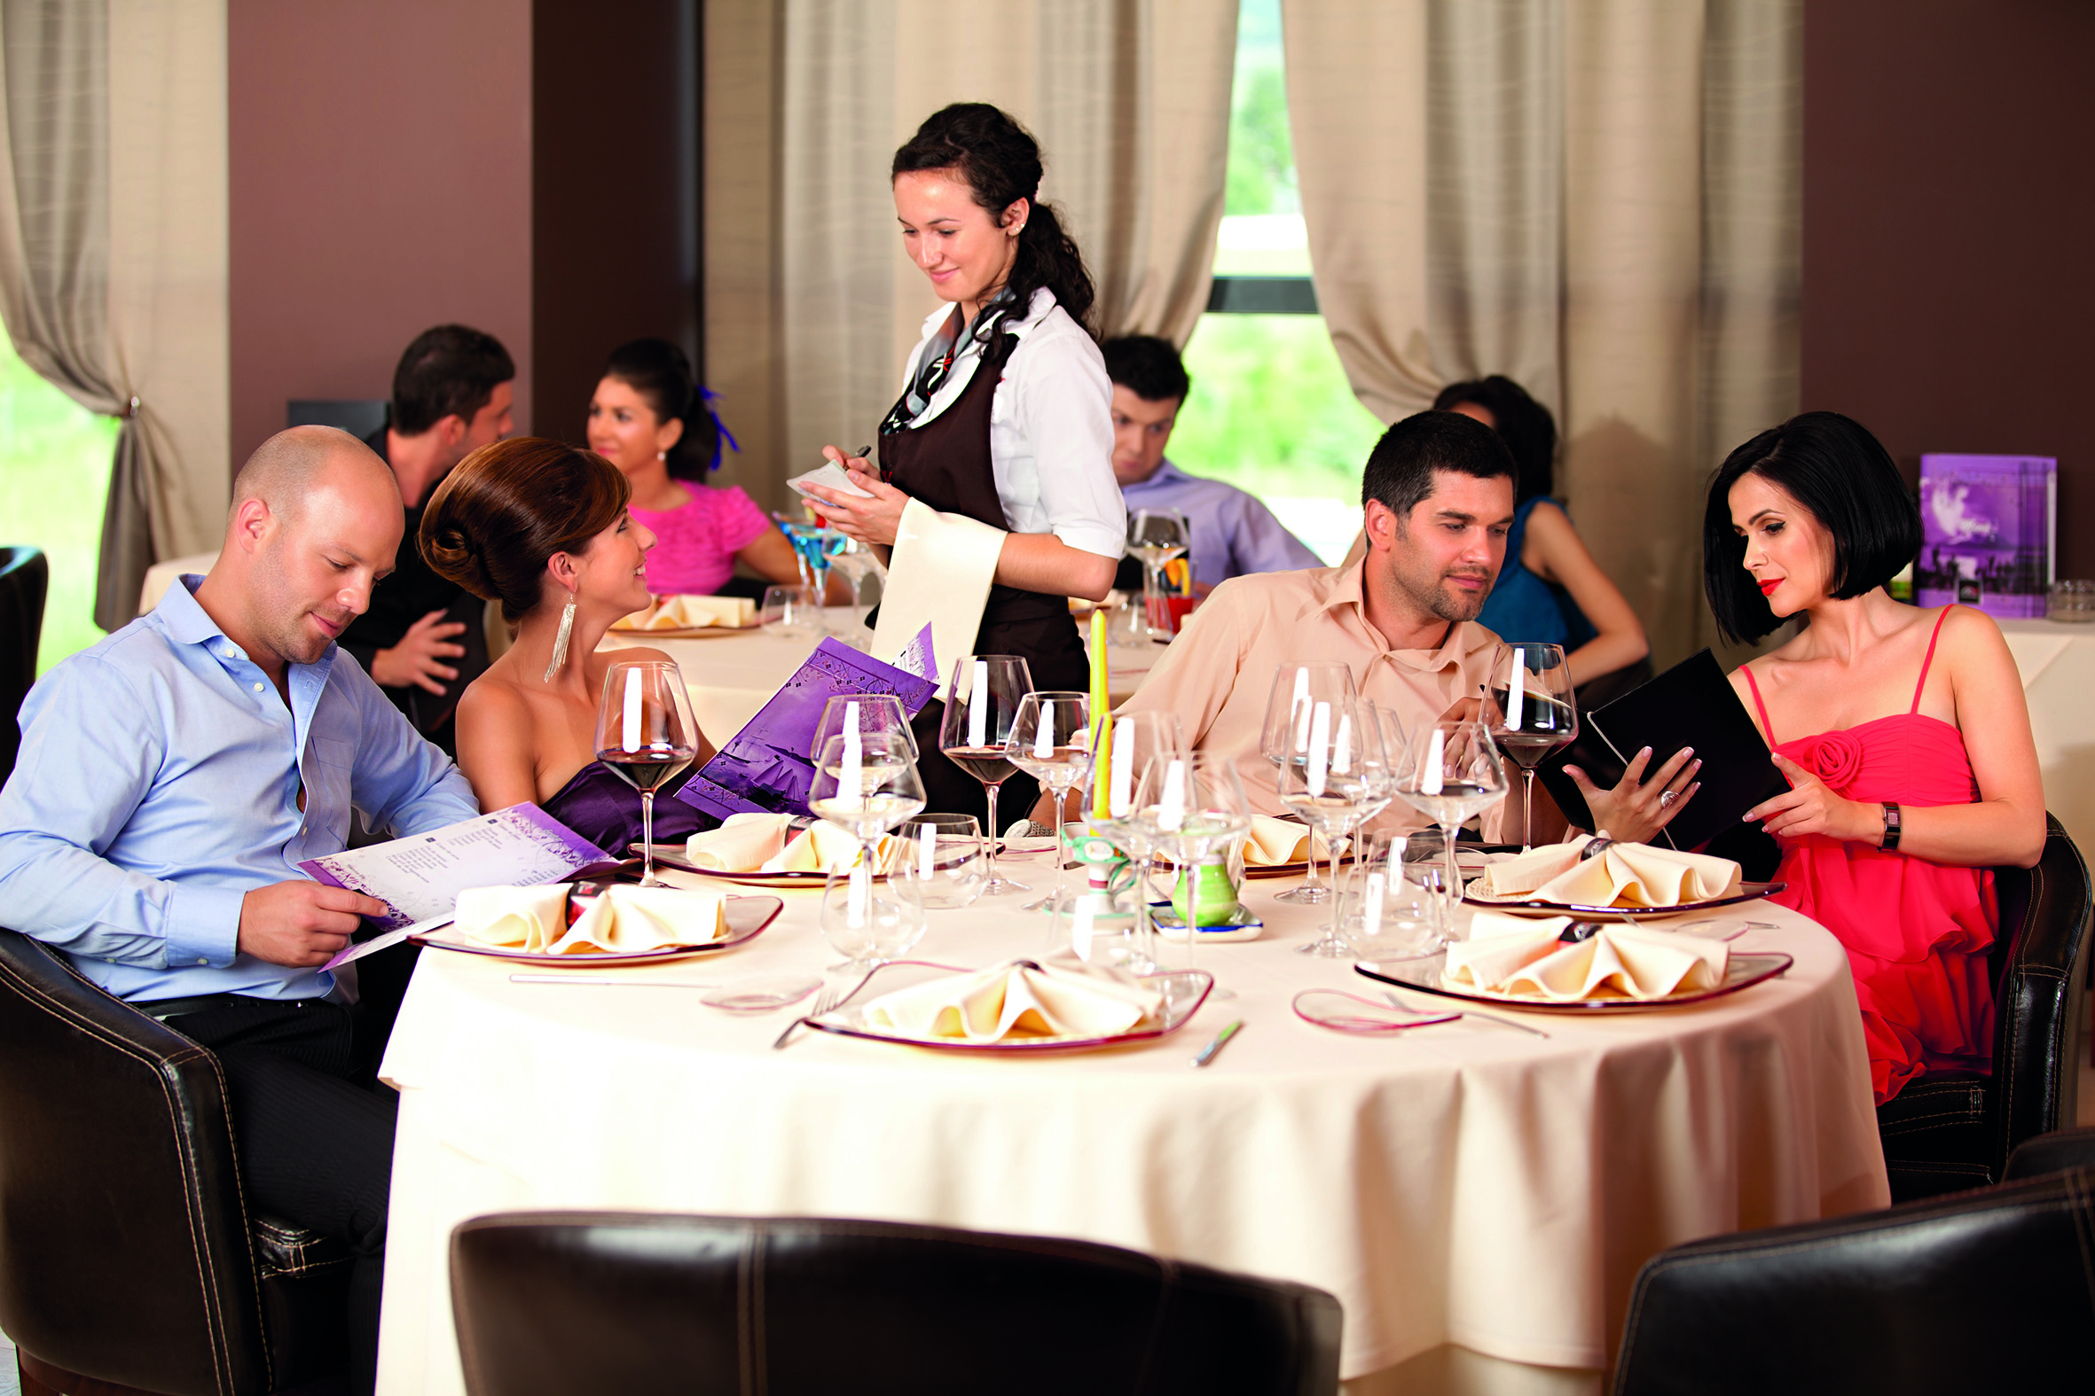 YES / NO
Jedeš li u restoranima?
c) Do you go to a shopping centre?  YES / NO
Odlaziš li u trgovački centar?

d) Do you go to a library? 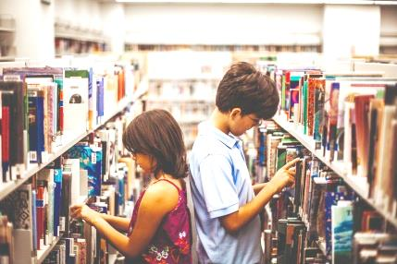 YES / NO
Posjećuješ li knjižnicu?

e) Do your parents buy food at the market? 
Kupuju li tvoji roditelji hranu na tržnici? YES / NO

- 3 PROJECT
Places in my town (Mjesta u mom gradu)

a) Think about your town. What places are there?
Talk to your classmate.
Razmisli o svom gradu. Koja su sve mjesta u tvom gradu?
Razgovaraj s prijateljem iz klupe o svom gradu i mjestima u svom gradu.

b) What are the places in your town? Answer the questions.
Find help in task 2.
Koja su sve mjesta u tvom gradu? Odgovori na pitanja.
Pomozi se riječima iz zadatka 2.

1 What is the main street in your town called?
The main street in my town is called _______________________________________
_______________________________________.
(napiši ime glavne ulice u tvom gradu)

2 What is there in the main street?
Is there a shop, a restaurant, a museum, a theatre?
There are/ is: _____________________________
_________________________________________
_______________________ in the main street.
(napiši što se sve nalazi u glavnoj ulici: trgovina, restoran, muzej, kazalište, itd.)

3 What is the name of your street?
The name of my street is________________________
_____________________________________________ .
(napiši ime svoje ulice)

4 What is in your street?
Is there a shop, a museum, a theatre, a restaurant?
There is _________________________________________
______________________________________________
____________________________ in my street.
(napiši koja su sva mjesta u tvojoj ulici: trgovina, restoran, muzej, kazalište, itd.)

c) Copy the sentences from task 3 b).
Prepiši rečenice iz zadatka 3 b) na prazne crte.

1 _______________________________________________
_______________________________________________

2 _______________________________________________
_______________________________________________
_______________________________________________

3 _______________________________________________
_______________________________________________

4 _______________________________________________
_______________________________________________
_______________________________________________

